**Spring Boot REST API – Task 2: Static Country Service (/country)**

**✅ Objective**

Create a REST API using Spring Boot that returns the details of **India** by reading a bean from the Spring XML configuration (country.xml).

**📘 Scenario**

* Method: GET
* URL: http://localhost:8083/country
* Output: JSON object for India
* Source: Spring XML bean with id="in"

**🧾 Controller: CountryController.java**

package com.cognizant.spring_learn.controller;

import com.cognizant.spring_learn.Country;

import org.slf4j.Logger;

import org.slf4j.LoggerFactory;

import org.springframework.context.ApplicationContext;

import org.springframework.context.support.ClassPathXmlApplicationContext;

import org.springframework.web.bind.annotation.GetMapping;

import org.springframework.web.bind.annotation.RestController;

@RestController

public class CountryController {

private static final Logger LOGGER = LoggerFactory.getLogger(CountryController.class);

@GetMapping("/country")

public Country getCountryIndia() {

LOGGER.info("START - getCountryIndia");

ApplicationContext context = new ClassPathXmlApplicationContext("country.xml");

Country country = (Country) context.getBean("in");

LOGGER.info("END - getCountryIndia");

return country;

}

}

**Screenshots**

1. Browser :

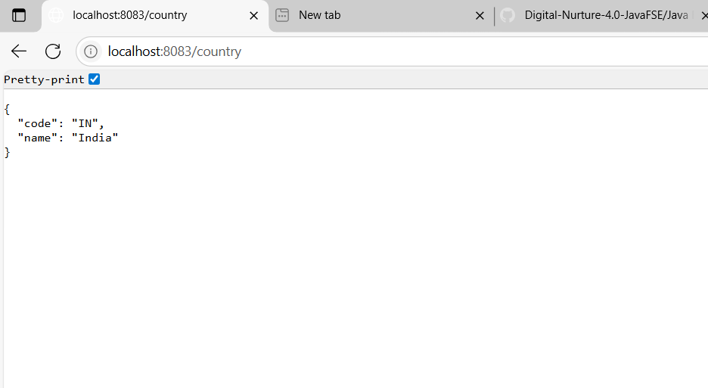

1. Console logs showing:

